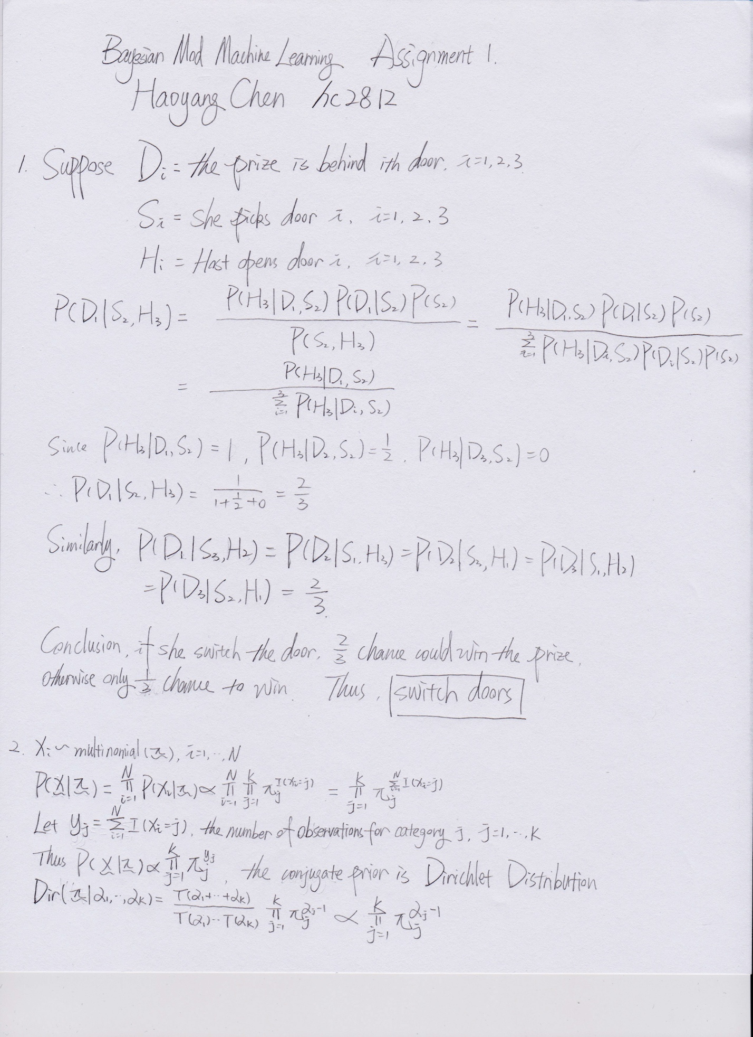

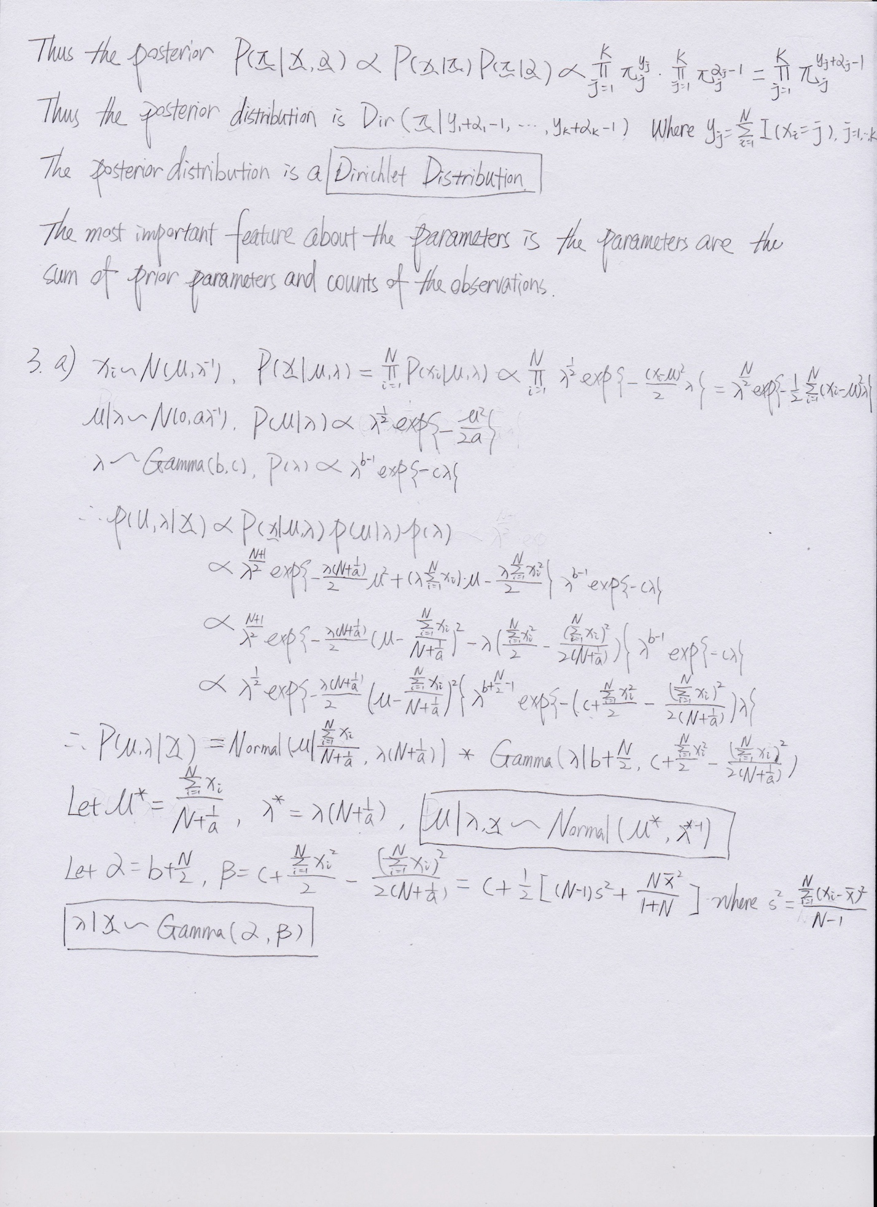

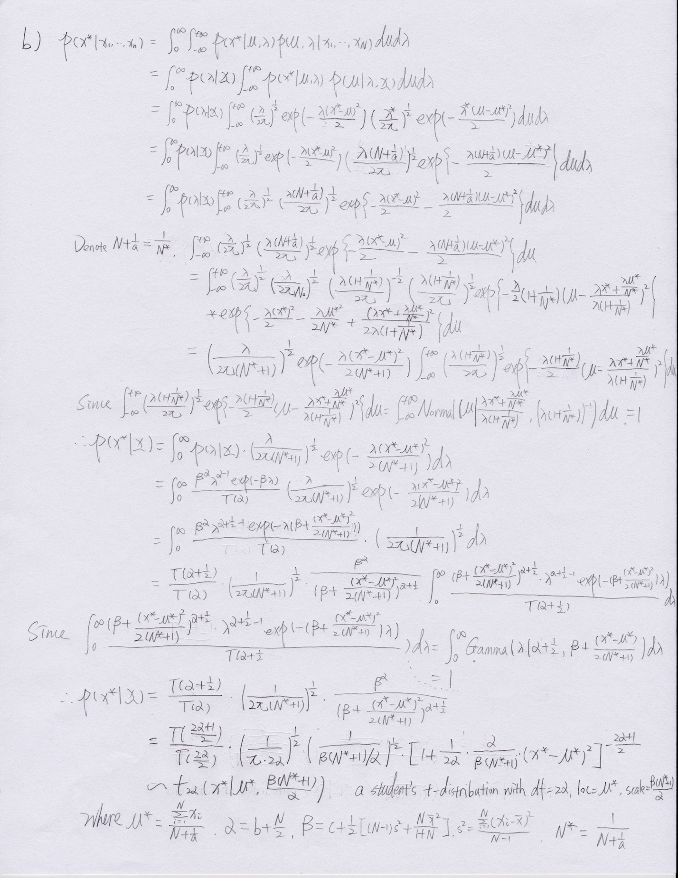

4.

a). Shown in the code

b). The cross table is shown below:

|  |  |  |
| --- | --- | --- |
|  | 0 | 1 |
| 0 | 930 | 52 |
| 1 | 82 | 927 |

Accuracy = 0.9327

c). 3 misclassified images

Image Index: 223

True label: 0

Predicted label: 1

Logit: 0.639793214237

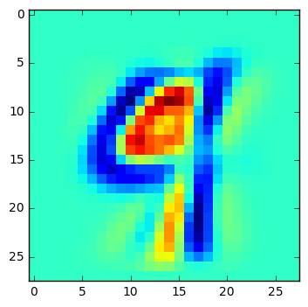

Image Index: 676

True label: 0

Predicted label: 1

Logit: 0.926222661075

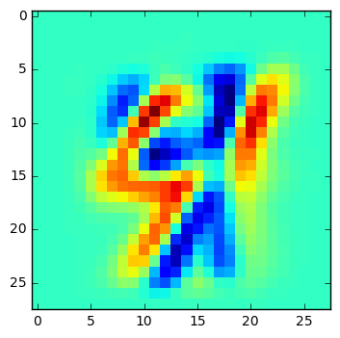

Image Index: 1842

True label: 1

Predicted label: 0

Logit: 1.79610067819

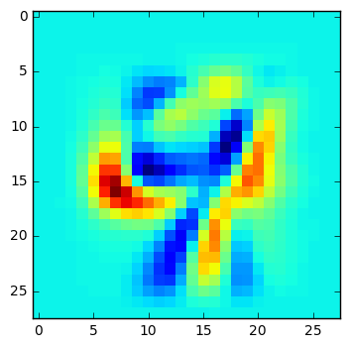

d). 3 most ambiguous predictions

Image Index: 822

True label: 0

Predicted label: 0

Logit: 1.00118731725

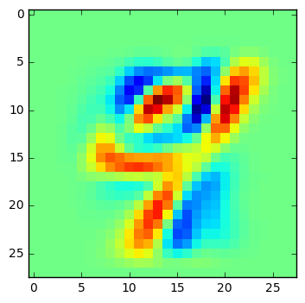

Image Index: 1130

True label: 1

Predicted label: 1

Logit: 0.990875806066

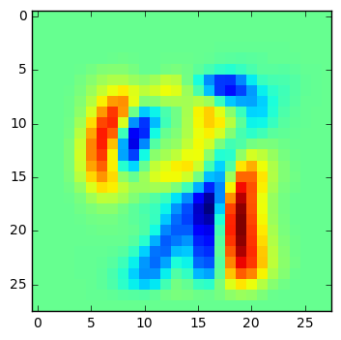

Image Index: 357

True label: 0

Predicted label: 0

Logit: 1.01456469643

